Team3@husky.neu.edu

[Email address]

Abstract

List of all the entities, it’s attributes and the relationship between them as per the ER model.

IMDB Database

Internet Movie Database

1. **MOVIES SCHEMA**
   1. **Table Movies.Movie:**

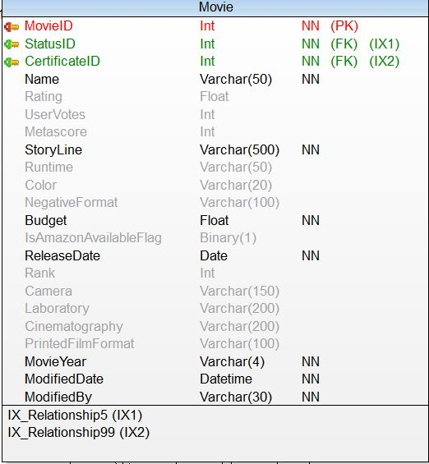

**Indexex:**

**PK_Movie_MovieID**

**FK_Movie_StatusID**

**FK_Movie_CertificateID**

* 1. **TABLE Movies.MovieShowInTheatre:**

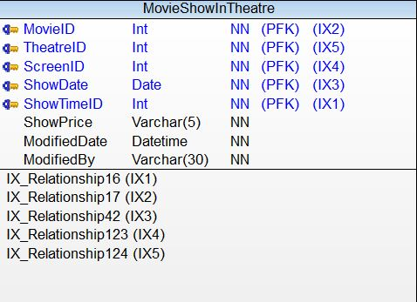

**Indexes:**

**PFK_MovieShowInTheatre_MovieID**

**PFK_MovieShowInTheatre_TheatreID**

**PFK_MovieShowInTheatre_ShowDate**

**PFK_MovieShowInTheatre_ShowTimeID**

* 1. **Table Movies.Theatre:**

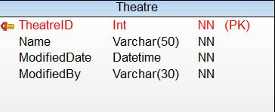

**Indexes:**

**PK_Theatre_TheatreID**

* 1. **Table Movies.ShowTime:**

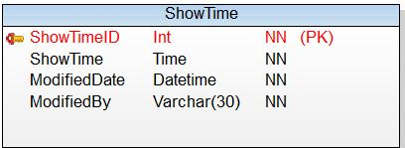

**Indexes:**

**PK_ShowTime_ShowTimeID**

* 1. **Table Movies.ShowDate:**

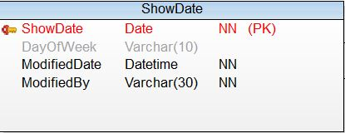

**Indexes:**

**PK_ShowDate_ShowDate**

* 1. **Table Movies.Screen:**

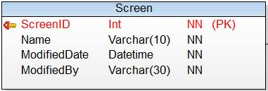

**Indexes:**

**PK_Screen_ScreenID**

* 1. **Table Movies.MovieTrailer:**

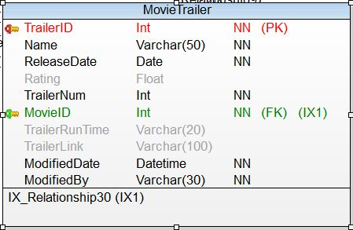

**Indexes:**

**PK_MovieTrailer_TrailerID**

**FK_MovieTrailer_MovieID**

* 1. **Table Movie.Genre:**

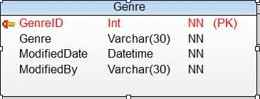

**Indexes:**

**PK_Genre_GenreID**

* 1. **Table Movies.MovieTVGenre:**

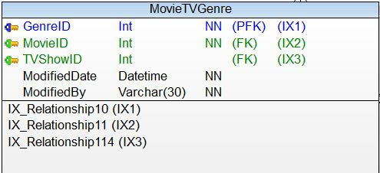

**Indexes:**

**PFK_MovieTVGenre_GenreID**

* 1. **Table Movies.MovieTVSoundMix:**

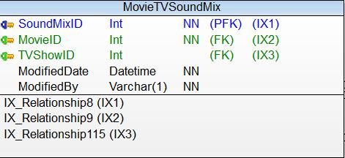

**Indexes:**

**PFK_MovieTVSoundMIX_SoundMixID**

**FK_MovieTVSoundMix_MovieID**

**FK_MovieTVSoundMix_TVShowID**

* 1. **Table Movies.MovieStatusRef:**

**MovieStatusRef have details about the status of the movie.**

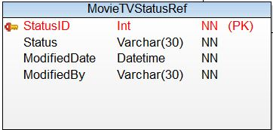

**Indexes**

**PK_MovieTVStatusRef_StatusID**

* 1. **Table Movies.ReleaseLanguage :**

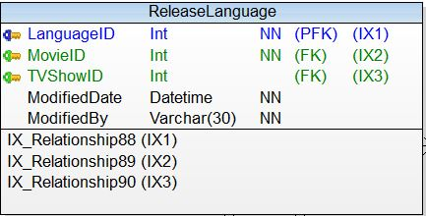

**Indexes:**

**PFK_ReleaseLanguage_LanguageID**

**FK_ReleaseLanguage_MovieID**

**FK_ReleaseLanguage_TVShowID**

* 1. **Table Movies.Language:**

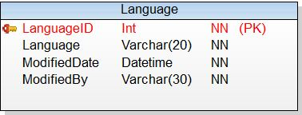

**Indexes:**

**PK_Langauge_LanguageID**

* 1. **Table Movies.Review:**

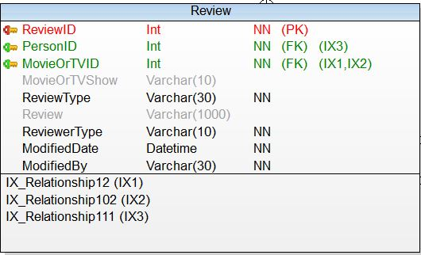

**Indexes:**

**PK_Review_ReviewID**

**FK_Review_PersonID**

**FK_Review_MoviewOrTVID**

* 1. **Table Movies.SoundMixRef:**

**SoundMixRef have SoundMixRefID and SoundMixName.**

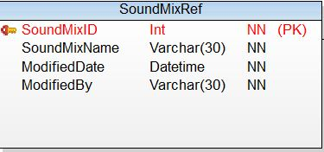

**Indexes:**

**PK_SoundMixRef_SoundMixRefID**

* 1. **Table Movies.BoxOfficeCollectionDate:**

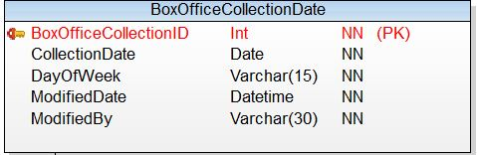

**Indexes:**

**PK_BoxOfficeCollectionDate_BoxOfficeCollectionID**

* 1. **Table Movies.BoxOfficeCollectionOfMovie:**

**BocOfficeCollectionOfMovie consists of MoviesID, BoxOfficeCollectionID, CollectionAmount.**

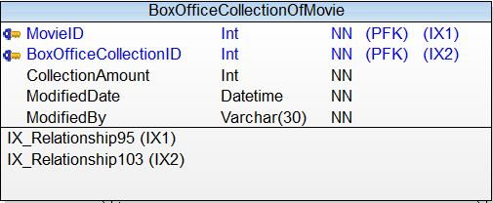

**Indexes**

**PFK_BoxOffiecCollectionOfMovie_MovieID**

**PFK_BoxOffiecCollectionOfMovie_BoxOfficeCollectionID**

* 1. **Table Movies.ProductionHouse:**

**ProductionHouse have ProductionID, ProductionName.**

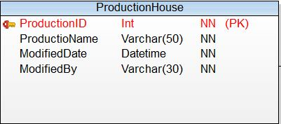

**Indexes:**

**PK_ProductionHouse_ProductionID**

* 1. **Table Movies.ProductionForMovieOrTV:**

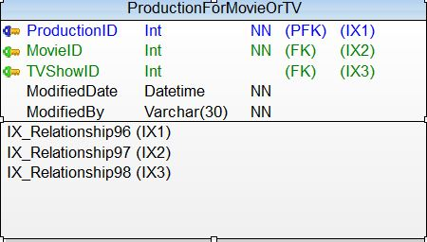

**Indexex:**

**PFK_ProductionForMovieOrTV_ProductionID**

**FK_ProductionForMovieOrTV_MovieID**

**FK_ProductionForMovieOrTV_TVShowID**

* 1. **Table Movies.DiskTypeRef:**

**DiskTypeRef have DiskTypeID and DiskType**

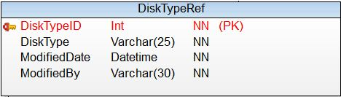

**Indexes:**

**PK_DiskTypeRef_DiskTypeID**

* 1. **Table Movies.MovieOrTVDiskType:**

**MovieDiskType have DateOfCreation, DiskTypeID, MovieID.**

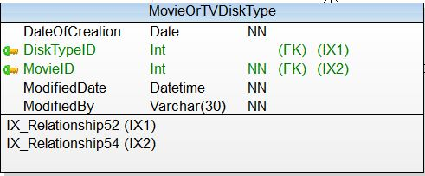

**Indexes:**

**PFK_MovieOrTVDiskType_DiskTypeID**

**FK_MovieOrTVDiskType_MovieD**

* 1. **Table Movies.FilmingLocation:**

**FilmingLocation have LocationID and Location.**

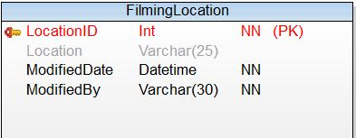

**Indexes:**

**FK_MovieOrTVDiskType_DiskTypeID**

**FK_MovieOrTVDiskType_MovieD**

* 1. **Table Movies.Certificate:**

**Certificate have CertificateID and name of Certificate and its description.**

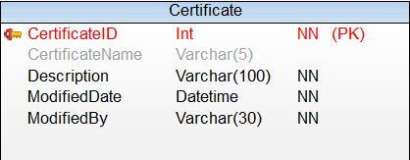

**Indexes:**

**PK_Certificate_CertificateID**

1. **PERSON SCHEMA**
   1. **Table PERSON.Person**

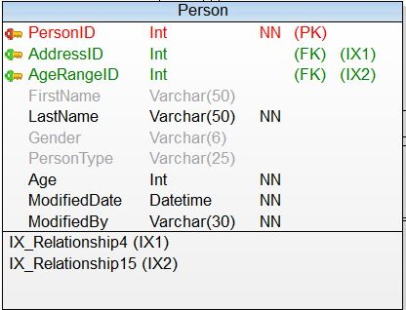

**Indexes:**

**PK_Person_PersonID**

**FK_Person_AddressID**

**FK_Person_AgeRangeID**

* 1. **Table PERSON.PersonAccount**

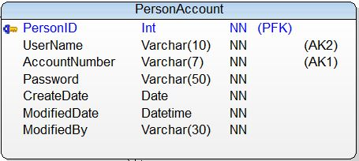

**Indexes:**

**PFK_PersonAccount_PersonID**

* 1. **Table PERSON.Spouse**

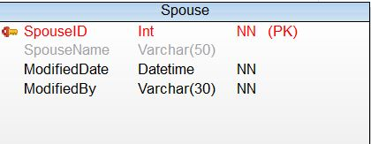

**Indexes:**

**PK_Spouse_SpouseID**

* 1. **Table PERSON.Celebrity**

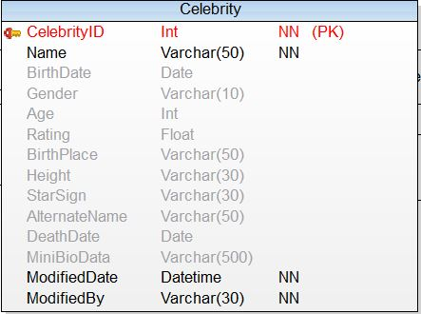

**Indexes:**

**PK_Celebrity_CeebrityID**

* 1. **Table PERSON.CelebritySpouse**

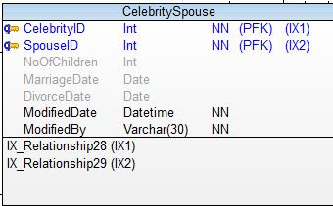

**Indexes:**

**PFK_CelebritySpouse_CelebrityID**

**PFK_CelebritySpouse_SpouseID**

* 1. **Table PERSON.CelebrityType**

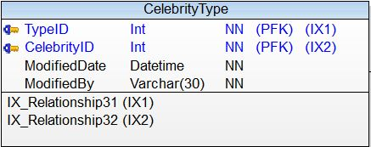

**Indexes:**

**PFK_CelebrityType_TypeID**

**PFK_CelebrityType_CelebrityID**

* 1. **Table PERSON.TypeOfCelebrity**

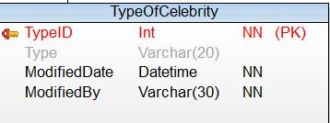

**Indexes:**

**PK_TypeOfCelebrity_TypeID**

* 1. **Table PERSON.AgeType**

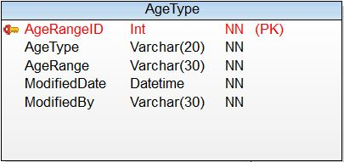

**Indexes:**

**PK_AgeType_AgeRangeID**

* 1. **Table PERSON.EmailAddress**

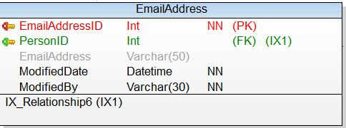

**Indexes:**

**PK_EmailAddress_EmailAddressID**

**FK_EmailAddress_PersonID**

* 1. **Table PERSON.Address**

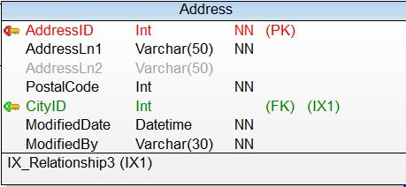

**Indexes:**

**PK_Address_AddressID**

**FK_Address_CityID**

* 1. **Table PERSON.City**

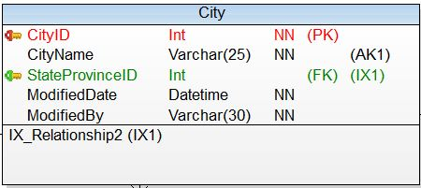

**Indexes:**

**PK_City_CityID**

**FK_City_StateProvinceID**

* 1. **Table PERSON.StateProvince**

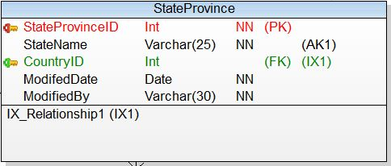

**Indexes:**

**PK_StateProvince_StateProvinceID**

**FK_StateProvince_CountryID**

* 1. **Table PERSON.Country**

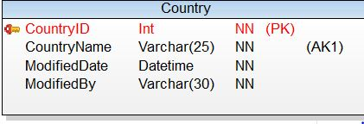

**Indexes:**

**PK_Country_CountryID**

1. **TELEVISON SCHEMA**
   1. **Table TELEVISION.TVShows**

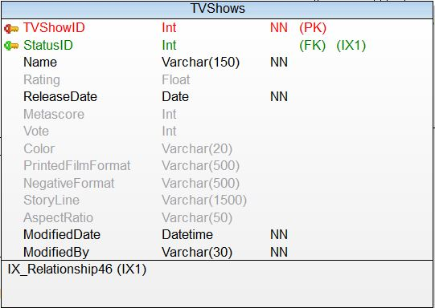

**Indexes:**

**PK_TVShows_TVShowID**

**FK_TVShows_StatusID**

* 1. **Table TELEVISION.TVShowTime**

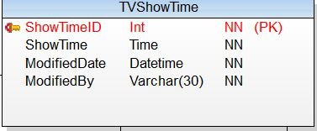

**Indexes:**

**PK_TVShowTime_ShowTimeID**

* 1. **Table TELEVISION.TVSeasonShow**

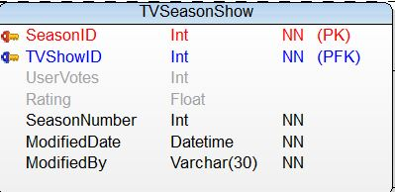

**Indexes:**

**PK_TVSeasonShow_SeasonID**

**PK_TVSeasonShow_TVShowID**

* 1. **Table TELEVISION.TVShowEpisode**

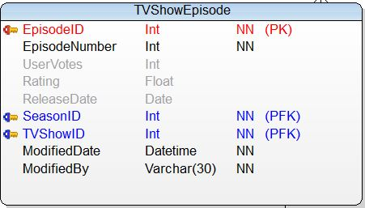

**Indexes:**

**PK_TVShowEpisode_EpisodeID**

**PFK_TVShowEpisode_SeasonID**

**PFK_TVShowEpisode_TVShowID**

* 1. **Table TELEVISION.Channel**

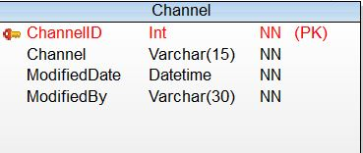

**Indexes:**

**PK_Channel_ChannelID**

* 1. **Table TELEVISION.TVShowOnChannel**

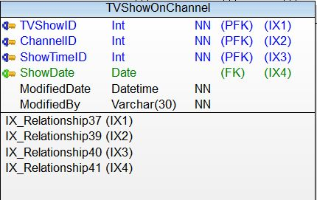

**Indexes:**

**PFK_TVShowOnChannel**

* 1. **Table TELEVISION.TVCelebrity**

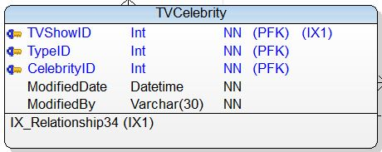

**Indexes:**

**PFK_TVCelebrity_TVShowID**

**PFK_TVCelebrity_TypeID**

**PFK_TVCelebrity_CelebrityID**

1. **NEWS SCHEMA**
   1. **Table NEWS.CelebrityNews**

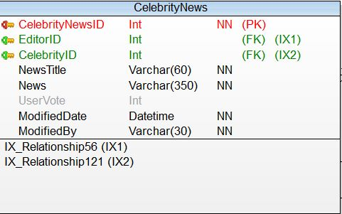

**Indexes:**

**PK_CelebrityNews_CelebrityNewsID**

**FK_CelebrityNews_EditorID**

**FK_CelebrityNews_CelebrityID**

* 1. **Table NEWS.Editor**

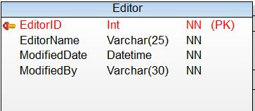

**Indexes:**

**PK_Editor_EditorID**

* 1. **Table NEWS.IndieNews**

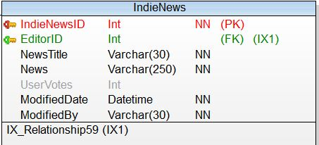

**Indexes:**

**PK_IndieNews_IndieNewsID**

**FK_IndieNews_EditorID**

* 1. **Table NEWS.MovieNews**

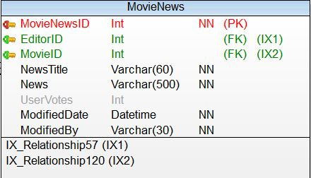

**Indexes:**

**PK_MovieNews_MovieNewsID**

**FK_MovieNews_EditorID**

**FK_MovieNews_MovieID**

* 1. **Table NEWS.NewsArticle**

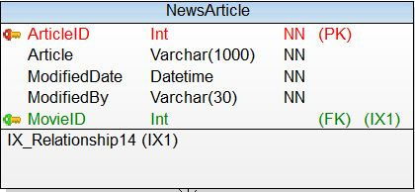

**Indexes:**

**PK_NewsArticle_ArticleID**

**FK_NewsArticle_MovieID**

* 1. **Table NEWS.NewsChannel**

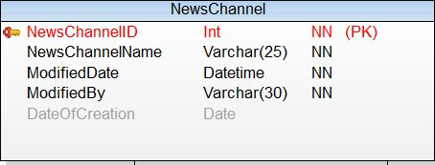

**Indexes:**

**PK_NewsChannel_NewsChannelID**

* 1. **Table NEWS.NewsOnChannel**

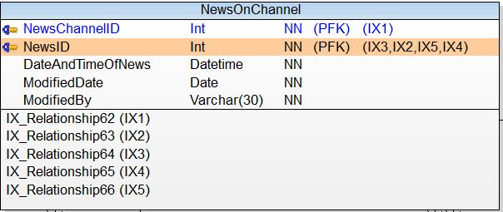

**Indexes:**

**PFK_NewsOnChannel_NewsChannelID**

**PFK_NewsOnChannel_NewSID**

* 1. **Table NEWS.TVNews**

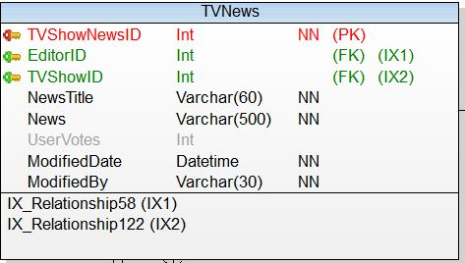

**Indexes:**

**PK_TVNews_TVShowNewsID**

**FK_TVNews_EditorID**

**FK_TVNews_TVShowID**

1. **AWARD SCHEMA**
   1. **Table AWARD.Award**

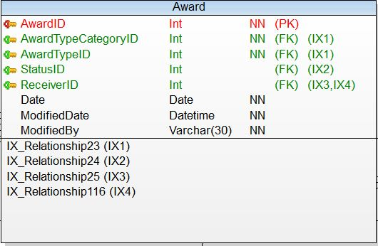

**Indexes:**

**PK_Award_AwardID**

**FK_Award_AwardTypeCategoryID**

**FK_Award_AwardTypeID**

**FK_Award_StatusID**

**FK_Award_ReceiverID**

* 1. **Table AWARD.AwardStatusRef**

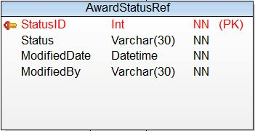

**Indexes:**

**PK_AwardStatusRef_StatusID**

* 1. **Table AWARD.AwardType**

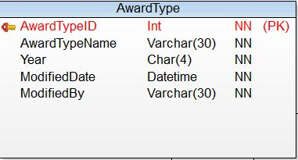

**Indexes:**

**PK_AwardType_AwardTypeID**

* 1. **Table AWARD.AwardTypeCategory**

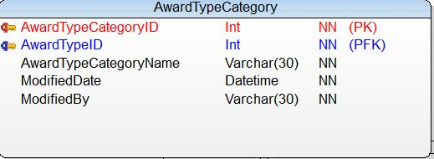

**Indexes:**

**PK_AwarDTypeCategory_AwardTypeCategoryID**

**PFK_AwardTypeCategory_AwardTypeID**

1. **REVIEW SCHEMA**
   1. **Table REVIEW.Critics**

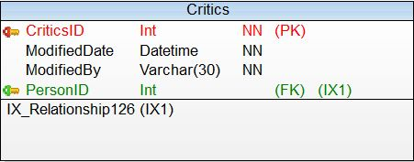

**Indexes:**

**PK_Critics_CriticsID**

**FK_Crirics_PersonID**

* 1. **Table REVIEW.Review**



**Indexes:**

**PK_Review_ReviewID**

**FK_Review_PersonID**

**FK_Review_MovieOrTVID**

* 1. **Table REVIEW.UserDetails**

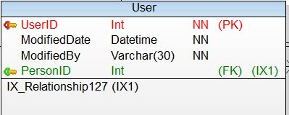

**Indexes:**

**PK_User_UserID**

**FK_User_PersonID**

1. **IMDBCOMMUNITY SCHEMA**
   1. **Table IMDBCOMMUNITY.MessageBoard**

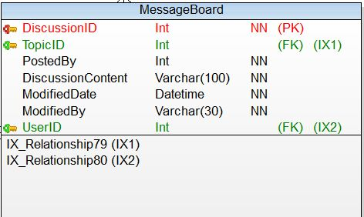

**Indexes:**

**PK_MessageBoard_DiscussionID**

**FK_MessageBoard_TopicID**

**FK_MessageBoard_UserID**

* 1. **Table IMDBCOMMUNITY.MessageBoardCategory**

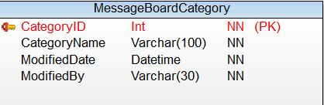

**Indexes:**

**PK_MessageBoardCategory_CategoryID**

* 1. **Table IMDBCOMMUNITY.MessageBoardTopic**

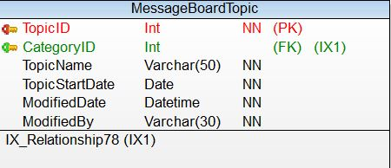

**Indexes:**

**PK_MessageBoardTopic_TopicID**

**FK_MessageBoardTopic_CategoryID**

* 1. **Table IMDBCOMMUNITY.PollOption**

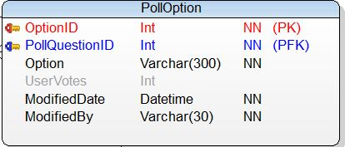

**Indexes:**

**PK_PollOption_OptionID**

**PFK_PollOption_PollQuestionID**

* 1. **Table IMDBCOMMUNITY.PollQuestion**

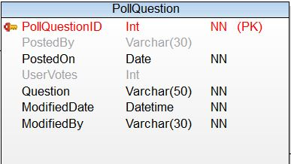

**Indexes:**

**PK_PollQuestion_PollQuestionID**

* 1. **Table IMDBCOMMUNITY.UserPoll**

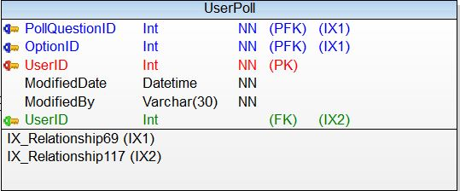

**Indexes:**

**PK_UserPoll_UserID**

**PFK_UserPoll_OptionID**

**PFK_UserPoll_PollQuestionID**